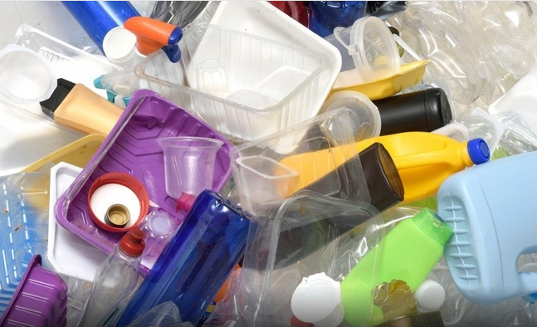

Producer Responsibility
Reduce plastic and hold polluters accountable
What is EPR for Packaging?
It’s a program to hold producers responsible for the cost of managing packaging waste. Producers decide what to use for packaging and consumers must accept it and pay for it. EPR for Packaging puts costs back on producers, so they make different choices. The goal is to redesign packaging to make it safer and more recyclable and to reduce packaging altogether.
Why do we need it?
Plastic pollution is a crisis, and more recycling can’t fix it. 40% of the waste stream is packaging. Local governments are responsible for recycling and have little control over what they must manage.
Producers decide what to use for packaging and they have no incentive to reduce, to eliminate toxic chemicals, or to design with recyclability in mind. Packaging producers continue to develop ‘new’ packaging which is often more complex. To get to a circular economy, we must standardize packaging, make it less complex, and get toxic chemicals out.

What will it do?
- Reduce the amount of packaging produced
- Increase the recyclability of packaging
- Increase reuse / refill options
- Remove toxic chemicals in packaging
- Increase post-consumer content in packaging
- Reduce litter and reduce trash going to landfills
- Create clear, consistent labeling
- Reduce hard-to-recycle packaging
How it works?
Brand owners pay a fee for the type and amount of packaging material they use. The fees are “eco-modulated” to incentivize reducing and redesigning packaging to make it more recyclable, compostable, or reusable.
Is this something new?
No, it’s already in use in the entire European Union and five Canadian provinces. Maine and Oregon passed EPR for Packaging bills in 2021.
How are fees used?
- Offset local government recycling costs
- Improve recycling infrastructure and education
- Pilot reuse / refill programs

Increase
* Reuse * Recycling * Recyclability * Recycled content
Decrease
* Confusion * Contamination * Toxic chemicals

